Title: “Water Spots”
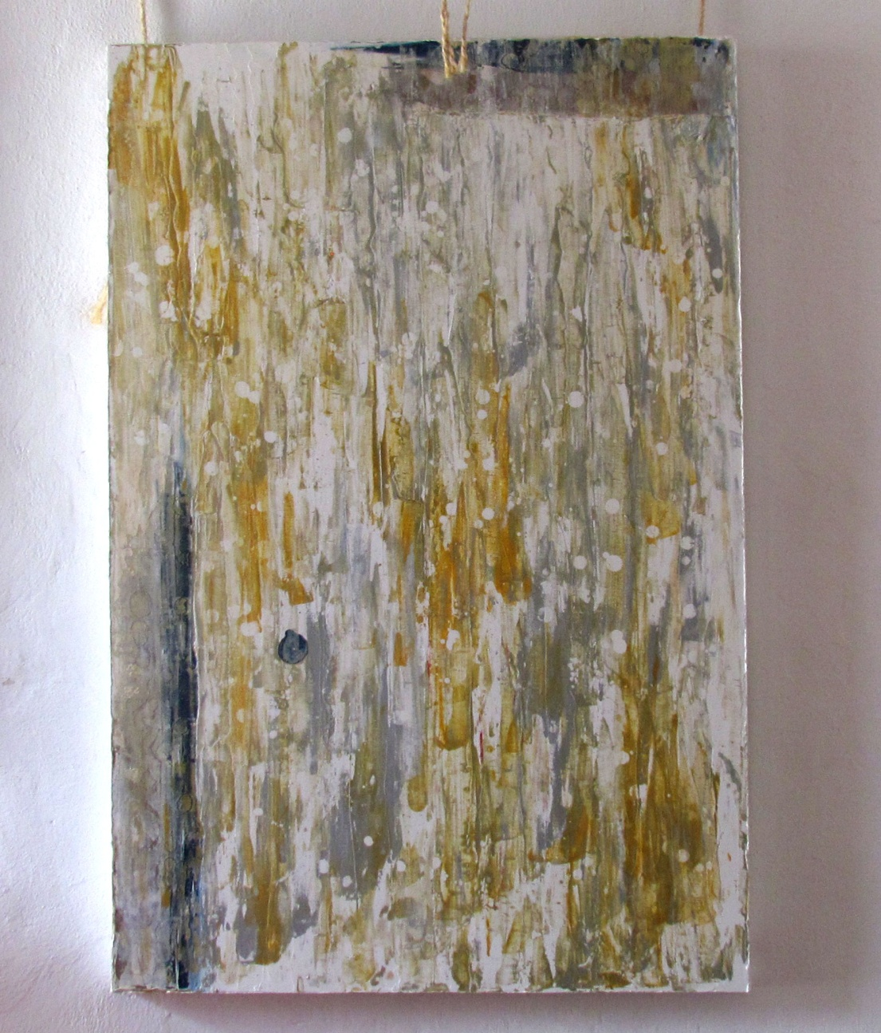
ARTIST: Steven Lemire
MEDIUM: Oil On Canvas
SIZE: 32"X48"
PRICE: $1,600
www.anartistsblog.com/water-spots/
604-831-0905 Steve Lemire
---------------------------------------------------------------------------------------------------------------------------------------


