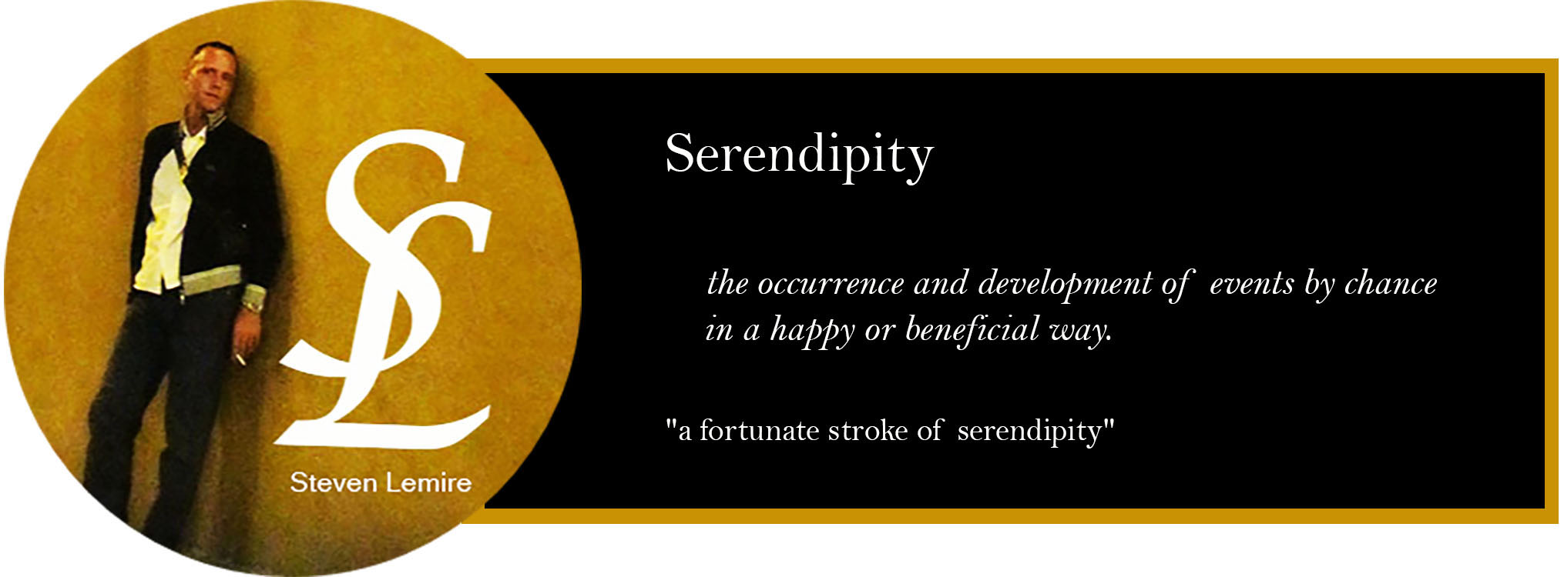
Merida, Yucatan based artist, Steven Lemire, migrated to Merida from the culturally diverse city of Vancouver, British Columbia, Canada in 2010. The youngest of 7 siblings, he inherited the talents of each sibling and amalgamated them into his own to find his diverse skills and abilities to make them his own. Steven has been honing his painting skills in modern/contemporary art since 2012 and retains the skill of using only spatulas to apply dense, three dimensional features, with oil paint, on canvas.

Originally a large scale event manager, food and event designer, Steven blended his oil painting skills with his thirty-five years of food and event experience, bringing about a perfect marriage of his two passions. Like spreading icing on a cake and applying thick and heavy paint applications
to tell a story, Steven’s hope is that it passes along the enjoyment he feels from creating something unique.

Steven has sold his artwork to clients in Canada, the U.S., Mexico and internationally. He has participated in multiple art shows, exhibits, collectives and fundraisers and continues to present his works of expression, as serendipity continues.

