An Interview with Steven Lemire
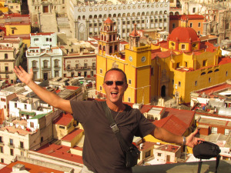 | About: Steven Lemire recently discovered his passion for painting and expressing himself, along with his wife, Sanda. He creates abstract paintings and will be showcasing them at this year’s expo.  How would you describe your work?  I would describe each piece of art as one of a kind. They’re uniquely painted, modern, contemporary oil paintings with an emphasis on depth, varied colors and deep textures. Each painting draws out various emotions and perceptions, especially when spot or focused mood lighting is added, which can give the piece more character.
What do you like about creating abstract art?
Creating abstract art affords me the opportunity of not being limited, which allows my emotions and environment to affect how the paint is applied. It’s like the old saying, “If it feels good, do it!”
How long does it usually take you to create a piece?
The time taken to complete a painting is mainly based on how long it takes the layers to dry. If I had a large enough studio, I think I would do multiple paintings at once, but 4 – 5 days is average if you don’t count waiting for drying times.
Do you usually go into a painting with an image or idea you want to bring to life, or do you create as you go?
I’ve tried to start with an idea in mind, but it doesn’t seem to help me reach my goal, so I usually paint as I go. Most of the pieces I start with an idea in mind become paintings covering paintings until the result is more than what was intended.
You work with your wife, Sanda. What is it like to work with your spouse, and how do you encourage each other as artists? Honestly, I don’t know if I would enjoy painting without her. Each time we paint, we share candlelit nights, amazing music, bottles of wine and a lot of laughter. On hot nights in Mexico, we take a late-night dip in the pool on painting breaks. It refreshes the mind and helps to create excitement and longer nights of painting!
How did living in Mexico influence you?  Living in Mexico influenced everything. Warm nights, bright starlit skies, happy people, a much slower pace of living and the lack of any stress helps to open the mind and let it flow. As a result, we hope to return this year and not look back. | 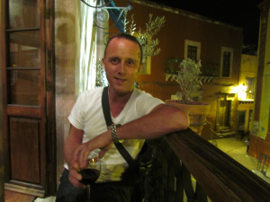Steven Lemire - Artist
Thank you for enjoying my work and sharing your time!

